Docker Private registry

The Registry is a stateless, highly scalable server side application that stores and lets you distribute Docker images. The Registry is open-source, under the permissive Apache license.

### USES

You should use the Registry if you want to:

1. tightly control where your images are being stored
2. fully own your images distribution pipeline
3. integrate image storage and distribution tightly into your in-house development workflow

## Requirements

Start your registry here. **--restart=always** means (If you want to use the registry as part of your permanent infrastructure, you should set it to restart automatically when Docker restarts or if it exits)

$ docker run -d -p 5000:5000 --restart=always --name registry registry:2

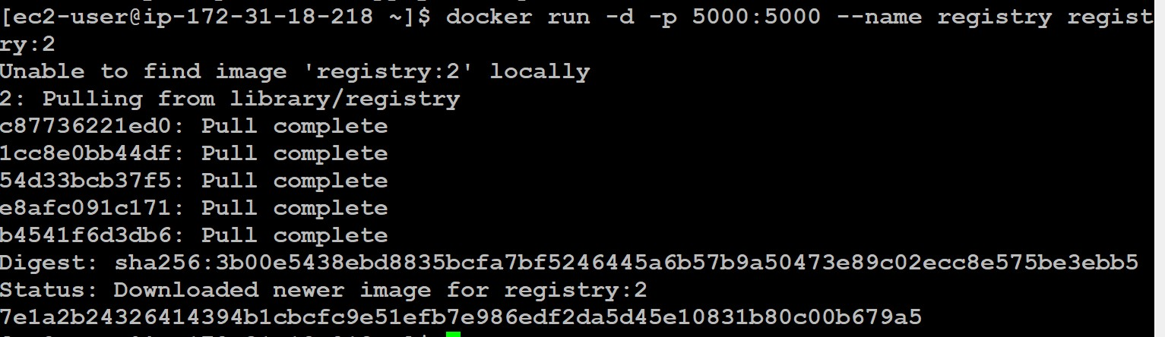

Check the registry container or not using below command.

$ docker ps

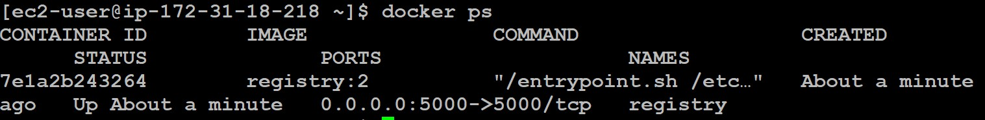

Pull (or build) some image from the hub

$ docker pull ubuntu

Tag the image so that it points to your registry

$ docker image tag ubuntu localhost:5000/my-ubuntu

push it your private registry

$ docker push localhost:5000/my-ubuntu

remove your local image and try to pull from local repository.

$ docker image remove ubuntu

$ docker image remove localhost:5000/my-ubuntu

$ docker pull localhost:5000/my-ubuntu

Now stop your registry and remove all data

$ docker container stop registry && docker container rm -v registry

Ref:

<https://docs.docker.com/registry/deploying/>

## Customize the storage location

By default, your registry data is persisted as a docker volume on the host filesystem. If you want to store your registry contents at a specific location on your host filesystem, such as if you have an SSD or SAN mounted into a particular directory, you might decide to use a bind mount instead. A bind mount is more dependent on the filesystem layout of the Docker host, but more performant in many situations. The following example bind-mounts the host directory **/mnt/registry** into the registry container at

**/var/lib/registry/.**

$ docker run -d \

-p 5000:5000 \

--restart=always \

--name registry \

-v /mnt/registry:/var/lib/registry \ registry:2

get the list of images in my private registry.

$ curl -X GET http://localhost:5000/v2/_catalog

If you want get the all tags form a particular image.

curl -X GET http://localhost:5000/v2/my-ubuntu/tags/list

if you want delete a tag first we need to get a catalog and tags and then use bellow command

curl -v --silent -H "Accept: application/vnd.docker.distribution.manifest.v2+json" -X GET http://localhost:5000/v2/my-ubuntu/manifests/latest 2>&1 | grep Docker-Content-Digest | awk '{print ($3)}'

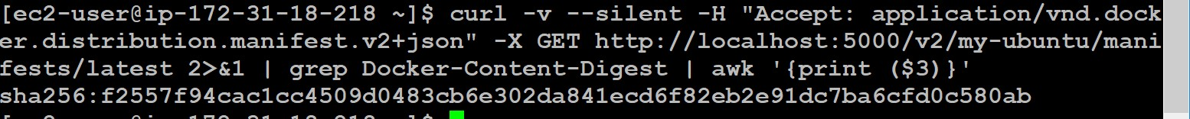

Run the command given below with manifest value:

curl -v --silent -H "Accept: application/vnd.docker.distribution.manifest.v2+json" -X DELETE http://127.0.0.1:5000/v2/my-ubuntu/manifests/ sha256:f2557f94cac1cc4509d0483cb6e302da841ecd6f82eb2e91dc7ba6cfd0c580ab

if you face below error

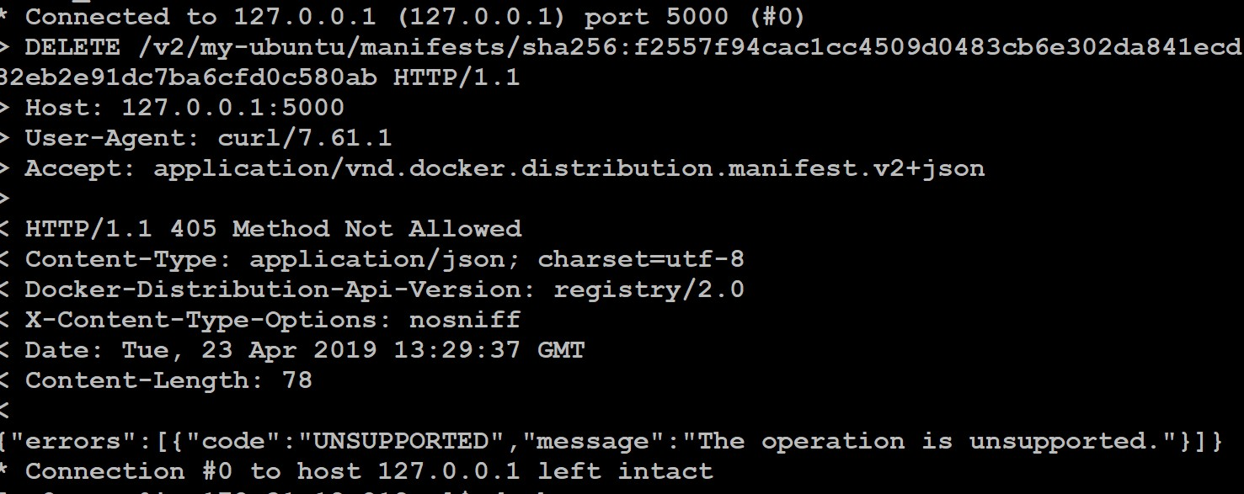

if you want to delete the images we must set the environment variable called

**REGISTRY_STORAGE_DELETE_ENABLED=true**

docker run -d -p 5000:5000 -e REGISTRY_STORAGE_DELETE_ENABLED=true -v

/mnt/registry:/var/lib/registry --restart=always --name registry registry:2

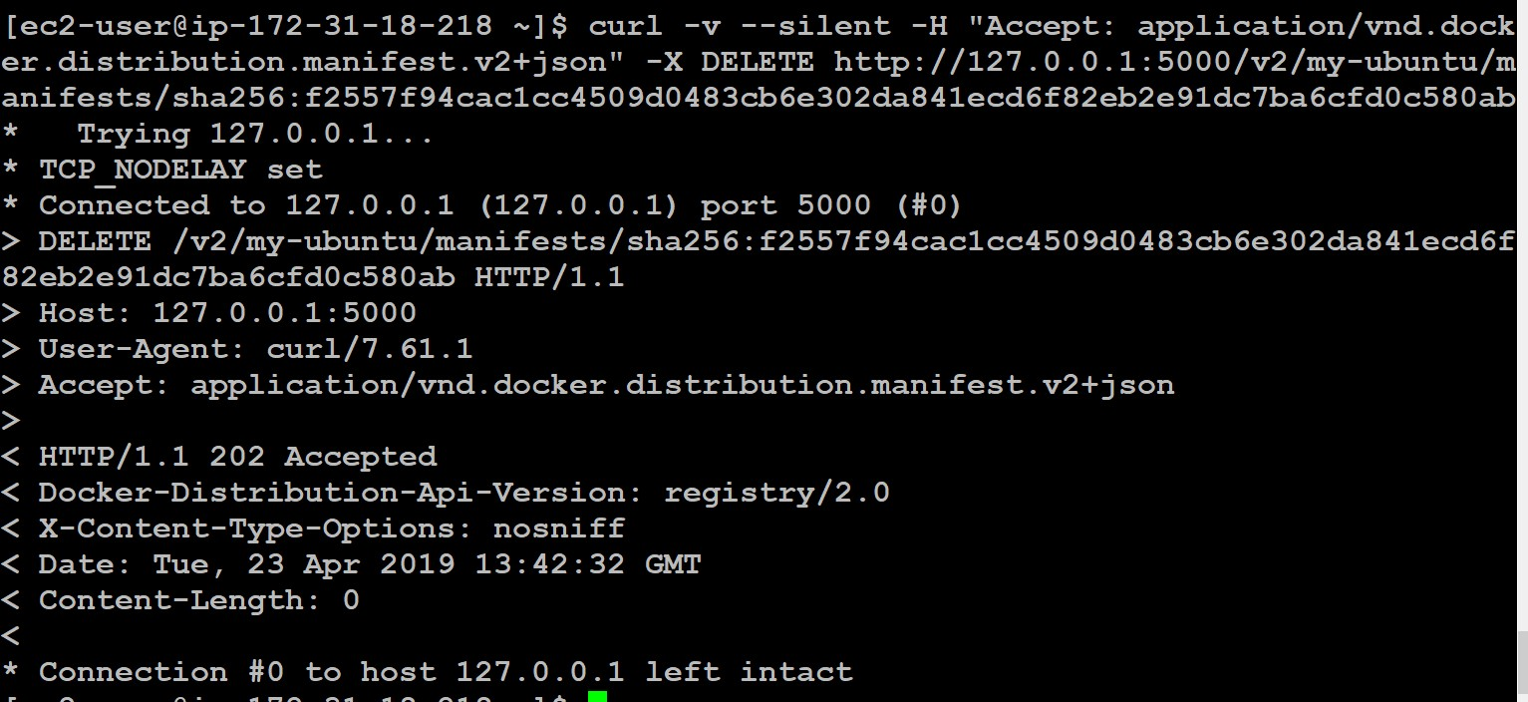

# Install Jenkins using docker

$ docker run -p 8080:8080 -p 50000:50000 jenkins

This will store the workspace in /var/jenkins_home. All Jenkins data lives in there - including plugins and configuration. You will probably want to make that a persistent volume (recommended):

docker run -d -p 8080:8080 -p 50000:50000 -u root -v /Jenkins_home:/var/jenkins_home jenkins/jenkins:lts

docker run --restart=always -d -p 8080:8080 -p 50000:50000 -u root -v

/Jenkins_home:/var/jenkins_home -v

/var/run/docker.sock:/var/run/docker.sock --name jenkins jenkins/jenkins:lts

You can run builds on the master (out of the box) but if you want to attach build slave servers: make sure you map the port: -p 50000:50000 - which will be used when you connect a slave agent.

docker run -d --restart=always -u root -p 8080:8080 -p 50000:50000 -v

/Jenkins_home:/var/jenkins_home -v $(which docker):/usr/bin/docker -v

/var/run/docker.sock:/var/run/docker.sock --name jenkins jenkins/jenkins:lts

docker run -d --restart=always -u root -p 8080:8080 -p 50000:50000 -v

/Jenkins_home:/var/jenkins_home -v $(which docker):/usr/bin/docker -v

/var/run/docker.sock:/var/run/docker.sock -v /home/ec2- user/.docker/config.json:/root/.docker/config.json --name jenkins jenkins/jenkins:lts

### Docker Private Repository as remote system

1. Install docker and run registry container in new machine.
2. go to docker host machine where we are building images and create a daemon.josn file.

/etc/docker/daemon.json

{

"insecure-registries" : ["publicip:5000"]

}

After adding json file must be restart docker service.

$ sudo service docker restart

Add the 5000 port in security group in registry server.

$ docker tag dbtest:v1 13.127.205.10:5000/dbtest:v1

$ docker push 13.127.205.10:5000/dbtest:v1

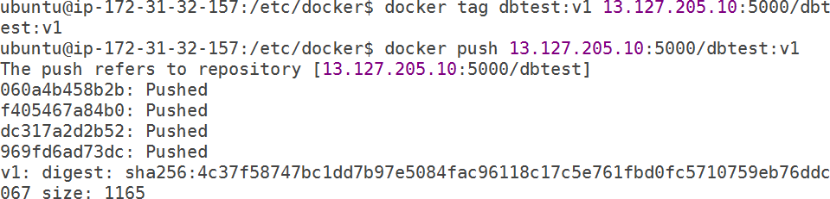

No we are able to push the images successfully.



1. Install the nexus in your machine as per our nexus documentation.
2. create docker repo server administration and configuration → Repositories → new Repository → select docker hosted

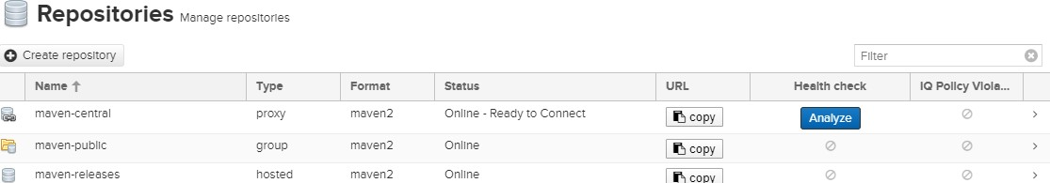

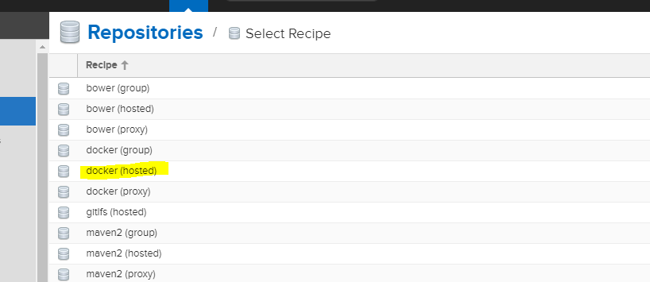

Enter the repo name http port which used to push images and select and enable docker v1 api and then create repository.

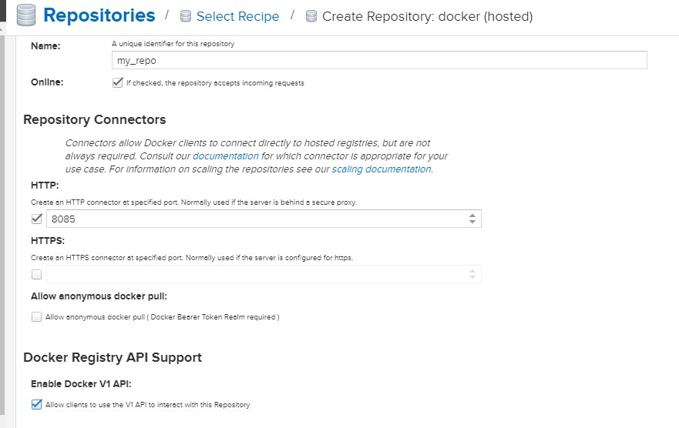

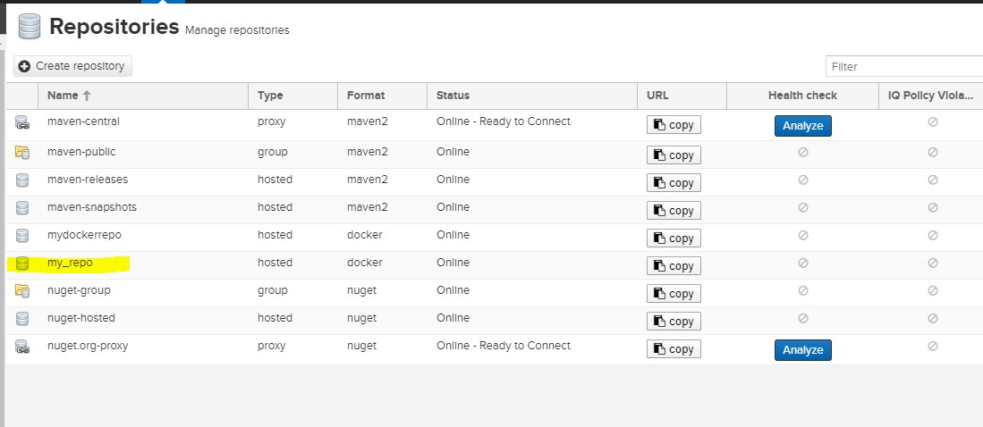

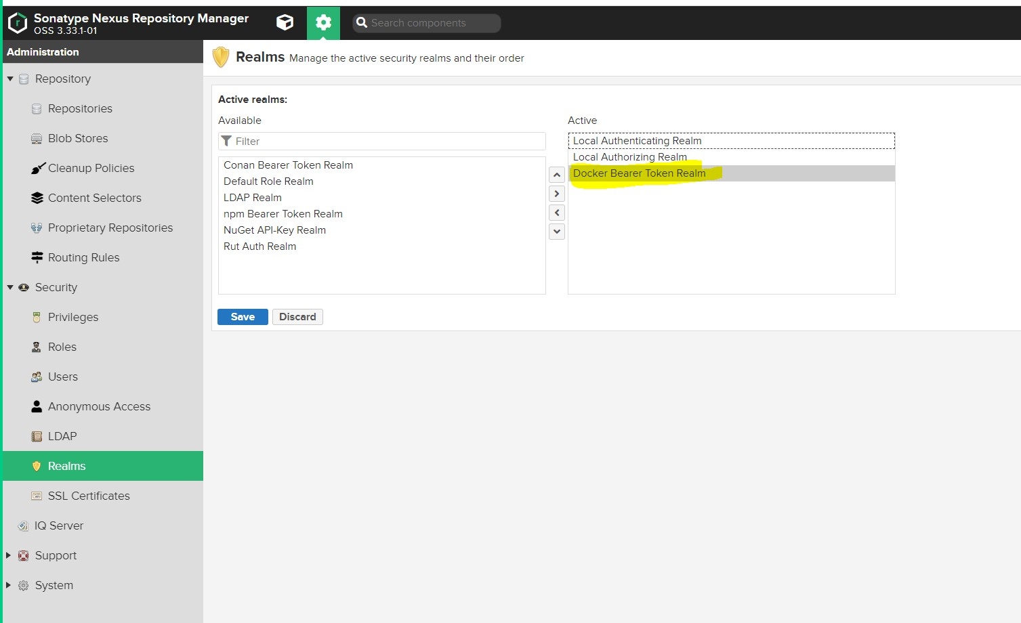

add the 8085 ports in to security group of nexus server.

1. create a image with <serverpublicip>:port docker tag myapp <publicip>:8085/myapp
2. should login with nexus credentials

docker login -u admin -p admin123 <publicip>:8085

Before pushing and login you must add the repo url in daemon.json file and then restart your docker deamon.

$ sudo service docker restart

/etc/docker/daemon.json

{

"insecure-registries" : ["publicip:8085"]

}

1. push the image

Docker push <publicip>:8085/myapp

# Push docker images to ECR repo

First need needs to setup aws cli

Create aws iam user→ add administration policy→ download AWS Access Key ID and AWS Secret Access Key.

If you are using ami linux2 we no need to install aws cli. If you are Ubuntu or some other os need to install aws cli refer below link or refer aws cli installation document.

<https://docs.aws.amazon.com/cli/latest/userguide/install-cliv2-linux.html#cliv2-linux-install>

you need to create repository **my-alpine** in aws ecr

$ aws ecr create-repository \

--repository-name my-alpine \

--image-scanning-configuration scanOnPush=true \

--region ap-south-1

create tag using below command

$ docker tag alpine 403959134869.dkr.ecr.ap-south-1.amazonaws.com/my-alpine

After you have installed and configured the AWS CLI, authenticate the Docker CLI to your default registry. That way, the **docker** command can push and pull images with Amazon ECR. The AWS CLI provides a **get-login** command to simplify the authentication process.

$ aws ecr get-login-password --region ap-south-1 | docker login --username AWS --password- stdin 403959134869.dkr.ecr.ap-south-1.amazonaws.com

You can see output like below

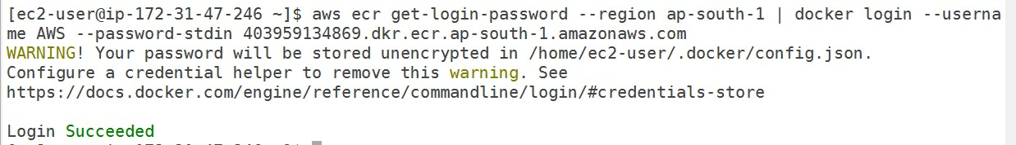

Then try to push docker image

$ docker push 403959134869.dkr.ecr.ap-south-1.amazonaws.com/my-alpine



### Docker private repo ui third party lib

<https://hub.docker.com/r/joxit/docker-registry-ui>

<https://opensourcelibs.com/lib/joxit-docker-registry-ui>

<https://github.com/Joxit/docker-registry-ui/issues/25>

docker run -d -p 5000:5000 -e REGISTRY_STORAGE_DELETE_ENABLED=true -v

`pwd`/config.yml:/etc/docker/registry/config.yml -v /mnt/registry:/var/lib/registry -- restart=always --name registry registry:2.7.1

docker run -d -p 80:80 -e URL=http://127.0.0.1:5000 -e DELETE_IMAGES=true joxit/docker-registry-ui:1.5-static

config.yml version: 0.1 log:

fields:

service: registry storage:

delete:

enabled: true cache:

blobdescriptor: inmemory filesystem:

rootdirectory: /var/lib/registry http:

addr: :5000 headers:

X-Content-Type-Options: [nosniff]

Access-Control-Allow-Origin: ['http://3.109.122.249']

Access-Control-Allow-Methods: ['HEAD', 'GET', 'OPTIONS', 'DELETE'] Access-Control-Allow-Headers: ['Authorization', 'Accept']

Access-Control-Max-Age: [1728000] Access-Control-Allow-Credentials: [true]

Access-Control-Expose-Headers: ['Docker-Content-Digest']

docker run -d -p 5000:5000 -e REGISTRY_STORAGE_DELETE_ENABLED=true -v

`pwd`/config.yml:/etc/docker/registry/config.yml -v /mnt/registry:/var/lib/registry -- restart=always --name registry registry:2.7.1

docker run -d -p 80:80 -e URL=http://65.1.94.194:5000 -e DELETE_IMAGES=true -- name=registry_ui joxit/docker-registry-ui:1.5-static